 | Pimpri Chinchwad Education Trust’s  Pimpri Chinchwad College of Engineering
Experiment No. 5
Experimentation details
Department: E&TC Academic Year: 2025-26 Semester-I
Class: B.Tech E&TC Course: VLSI Design Lab

Name of Student:
Div and Batch:
Roll No:
Title of the Experiment:
Model and verify 8-bit ALU using VHDL and implement on FPGA and evaluate power and timing performance.

Software Requirements: Xilinx 14.7 ISE Design Suite
Hardware Requirements: Xilinx Spartan-6 XC6SLX45 FPGA

VHDL Code for 8-bit ALU

library IEEE;
use IEEE.STD_LOGIC_1164.ALL;
use IEEE.STD_LOGIC_ARITH.ALL;
use IEEE.STD_LOGIC_UNSIGNED.ALL;

entity alu_lab8 is
Port (A,B : in STD_LOGIC_VECTOR (7 downto 0);
sel : in STD_LOGIC_VECTOR (2 downto 0);
Y : out STD_LOGIC_VECTOR (7 downto 0));
end alu_lab8;

architecture Behavioral of alu_lab8 is
begin
process(A,B,sel)
begin
case sel is
when "000" => Y <=A+B;
when "001" => Y <=A-B;
when "010" => Y <=A AND B;
when "011" => Y <=A NAND B;
when "100" => Y <=A XOR B;
when "101" => Y <=A XNOR B;
when "110" => Y <=A OR B;
when "111" => Y <=A;
when others => Y <="ZZZZZZZZ";
end case;
end process;
end Behavioral;

RTL Schematic
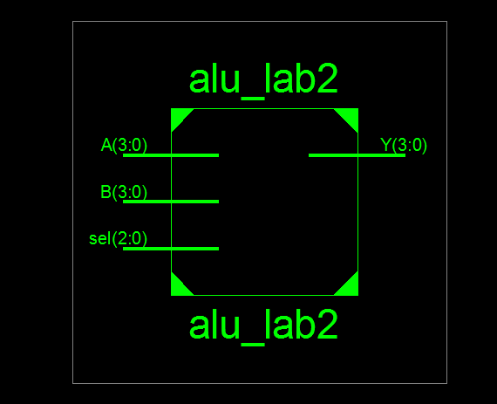
Detailed Schematic
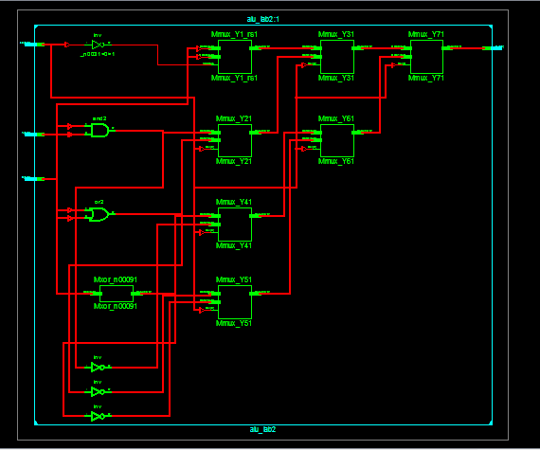

VHDL Test Bench
LIBRARY ieee;
USE ieee.std_logic_1164.ALL;

ENTITY alu IS
END alu;

ARCHITECTURE behavior OF alu IS

-- Component Declaration for the Unit Under Test (UUT)

COMPONENT alu_lab8
PORT(
A : IN std_logic_vector(7 downto 0);
B : IN std_logic_vector(7 downto 0);
sel : IN std_logic_vector(2 downto 0);
Y : OUT std_logic_vector(7 downto 0)
);
END COMPONENT;
--Inputs
signal A : std_logic_vector(7 downto 0) := (others => '0');
signal B : std_logic_vector(7 downto 0) := (others => '0');
signal sel : std_logic_vector(2 downto 0) := (others => '0');
--Outputs
signal Y : std_logic_vector(7 downto 0);

BEGIN
-- Instantiate the Unit Under Test (UUT)
uut: alu_lab8 PORT MAP (
A => A,
B => B,
sel => sel,
Y => Y
);
PROCESS
BEGIN
A<="10110011";
B<="01000100";
sel<="000";
wait for 20ns;
sel<="001";
wait for 20ns;
sel<="010";
wait for 20ns;
sel<="011";
wait for 20ns;
sel<="100";
wait for 20ns;
sel<="101";
wait for 20ns;
sel<="110";
wait for 20ns;
sel<="111";
wait;
end process;
END;
Simulation Results
4-bit ALU

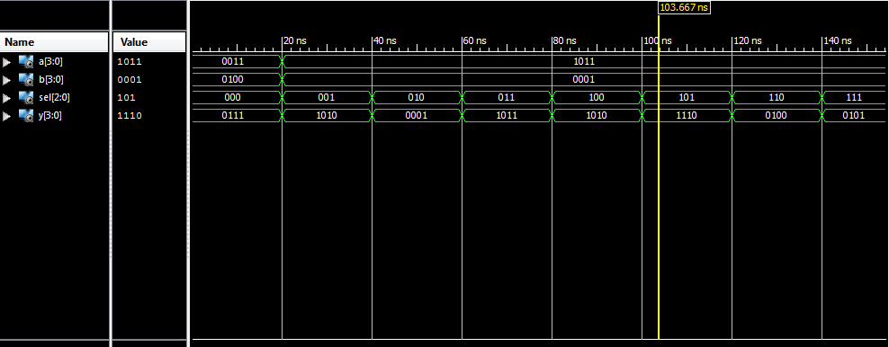

Implementation on Spartan 6
2-bit ALU
library IEEE;
use IEEE.STD_LOGIC_1164.ALL;
use IEEE.STD_LOGIC_ARITH.ALL;
use IEEE.STD_LOGIC_UNSIGNED.ALL;
entity Expt_1b is
Port ( A : in STD_LOGIC_VECTOR(1 downto 0);
B : in STD_LOGIC_VECTOR(1 downto 0);
sel : in STD_LOGIC_VECTOR(2 downto 0);
Y : out STD_LOGIC_VECTOR(1 downto 0));
end Expt_1b;

architecture Behavioral of Expt_1b is
begin
process(A,B,sel)
begin
case sel is
when "000" => Y <=A+B;
when "001" => Y <=A-B;
when "010" => Y <=A AND B;
when "011" => Y <=A NAND B;
when "100" => Y <=A XOR B;
when "101" => Y <=A XNOR B;
when "110" => Y <=A OR B;
when "111" => Y <=A;
when others => Y <="ZZ";
end case;
end process;
end Behavioral;

Device Specifications to be selected while implementing:
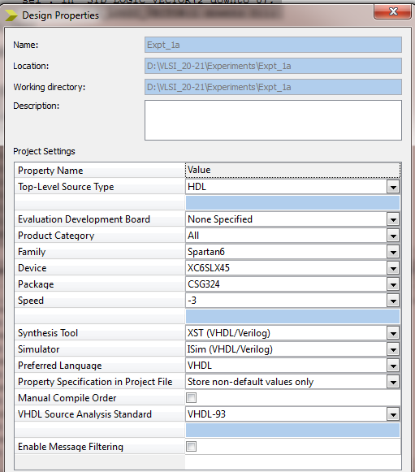
Implementation Constraint File
Net"A<0>"LOC="A10";
Net"A<1>"LOC="D14";
Net"B<0>"LOC="C14";
Net"B<1>"LOC="P15";
Net"SEL<0>"LOC="P12";
Net"SEL<1>"LOC="R5";
Net"SEL<2>"LOC="T5";
Net"Y<0>"LOC="U18";
Net"Y<1>"LOC="M14";

Implementation Successful
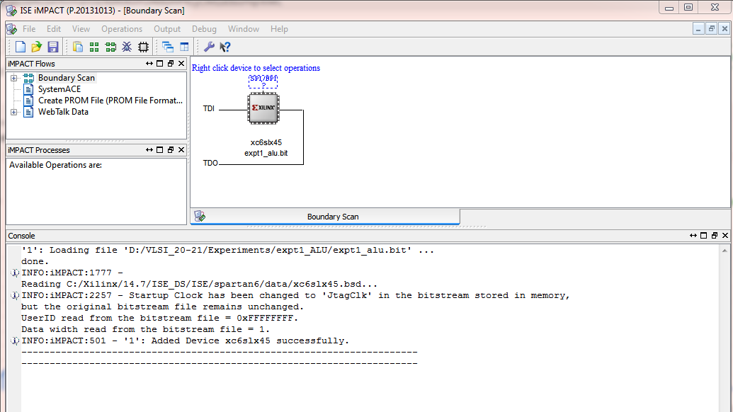

Hardware Snapshots
Digilent ATLYS Spartan 6 FPGA Board
